Algeria

## Freedom House political status

The data set shows the Freedom House political scores and status of the country each year.

## # A tibble: 19 x 5  
## country iso3c date mean status   
## <chr> <chr> <dbl> <dbl> <chr>   
## 1 Algeria DZA 1996 6 Not Free  
## 2 Algeria DZA 1998 5.5 Not Free  
## 3 Algeria DZA 2000 5.5 Not Free  
## 4 Algeria DZA 2002 5.5 Not Free  
## 5 Algeria DZA 2003 5.5 Not Free  
## 6 Algeria DZA 2004 5.5 Not Free  
## 7 Algeria DZA 2005 5.5 Not Free  
## 8 Algeria DZA 2006 5.5 Not Free  
## 9 Algeria DZA 2007 5.5 Not Free  
## 10 Algeria DZA 2008 5.5 Not Free  
## 11 Algeria DZA 2009 5.5 Not Free  
## 12 Algeria DZA 2010 5.5 Not Free  
## 13 Algeria DZA 2011 5.5 Not Free  
## 14 Algeria DZA 2012 5.5 Not Free  
## 15 Algeria DZA 2013 5.5 Not Free  
## 16 Algeria DZA 2014 5.5 Not Free  
## 17 Algeria DZA 2015 5.5 Not Free  
## 18 Algeria DZA 2016 5.5 Not Free  
## 19 Algeria DZA 2017 5.5 Not Free

## Freedom House classification of political change

The data set shows the GDP growth and the ecomic growth classification of the country each year.

## # A tibble: 19 x 4  
## country iso3c date politicalChangeFH  
## <chr> <chr> <dbl> <chr>   
## 1 Algeria DZA 1996 no change   
## 2 Algeria DZA 1998 democratization   
## 3 Algeria DZA 2000 no change   
## 4 Algeria DZA 2002 no change   
## 5 Algeria DZA 2003 no change   
## 6 Algeria DZA 2004 no change   
## 7 Algeria DZA 2005 no change   
## 8 Algeria DZA 2006 no change   
## 9 Algeria DZA 2007 no change   
## 10 Algeria DZA 2008 no change   
## 11 Algeria DZA 2009 no change   
## 12 Algeria DZA 2010 no change   
## 13 Algeria DZA 2011 no change   
## 14 Algeria DZA 2012 no change   
## 15 Algeria DZA 2013 no change   
## 16 Algeria DZA 2014 no change   
## 17 Algeria DZA 2015 no change   
## 18 Algeria DZA 2016 no change   
## 19 Algeria DZA 2017 no change

## Freedom House score trend

The plot shows the Freedom House scores trend of the country.

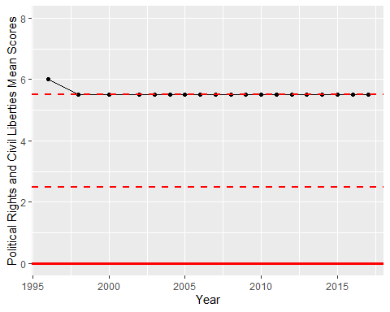

Freedom House Score Trend